**Exploratory analysis**

Data exploration helps infer useful information and predict important aspects of crime detection and prevention. At the same time, the nature of the data largely determines what kind of prediction tasks can be performed. A preliminary analysis of data was performed to identify useful features for building a predictive model. It revealed some interesting trends and patterns which are documented below.

Crime and Arrest rate by year :

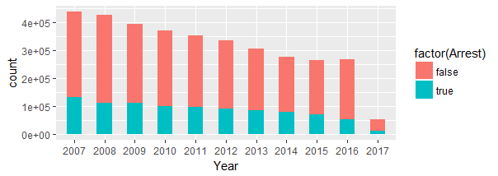

Above Figure, represent the crime statistics for Chicago taking into account the number of crime and arrest rate over the period of years. This helped to give a better overall summary of the crimes occurrence and arrests that happened throughout the year 2007-2017. It is clear from the graph that the arrest rates and the crime rates are decreasing over year.

Crime and Arrest by Weekday :

The below visualizations depicts the number of crime occurrences and arrests on a particular day of week.

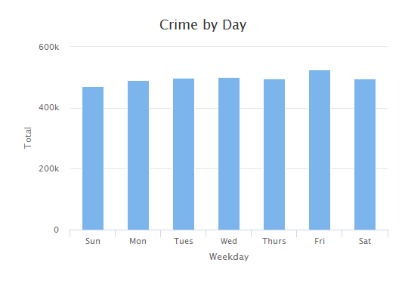

Figure 'Crime by Day' shows the number of crime occurrence over the weekdays in Chicago. Where Friday has the maximum number of crimes occurrence and Sunday has the least number of crimes occurrence.

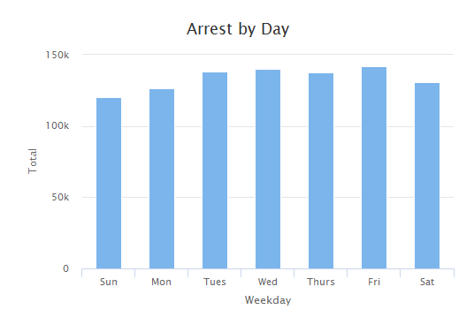

Figure 'Arrest by Day' shows the number of arrest of crimes over the weekdays in Chicago. Where Friday has the maximum number of crimes arrest and Sunday has the least number of crimes arrest.

Overall, there are some similarities between the occurrence of crime and arrest rate in two figures.

Crime and Arrest by Primary Type of crime :

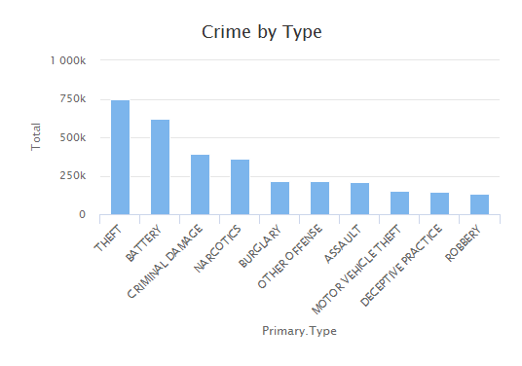

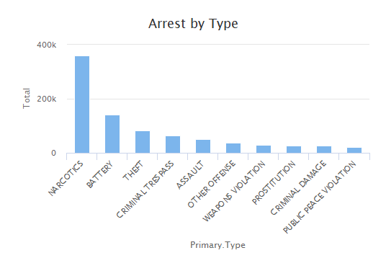

Above Figures provide a statistical comparison between numbers of particular crime type committed and arrest rate of the crime type. We chose to limit the comparison to top 10 crimes and arrests in order to get a fair comparison. While most of the crime occurrence belong to Theft crime type we graphed over the arrest rate and found that the arrests rate are more for narcotics crime type among total number of crimes. It helps to better understand and visualize the numbers of crime committed and compare the same with the arrest rate for that particular crime.

Crime by Location :

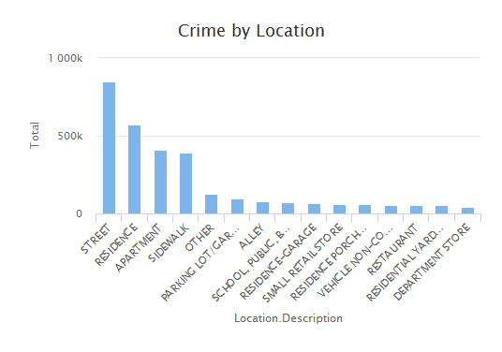

This Figure shows the number of crime occurrences over different locations in Chicago. With many locations, we chose to display top fifteen different areas. Street having the most crime rate among the 158 locations while Department store has the minimum crime rate in top 15 areas of the total crimes. Overall, the street seems to be the most dangerous area.

These insights help to understand the distribution of incident and some interesting trends and patterns.